

Nakile Home for Special Care
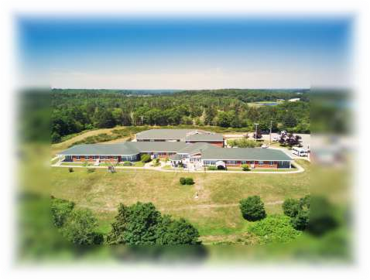
Information and Admissions Booklet
Welcome to Nakile
On behalf of the Nakile Team, we wish to welcome you to your new “home away from home”. We are pleased that you have come to Nakile, and we would like to make your stay with us as comfortable as possible.

As this change is a big adjustment in your life, we would like to reassure you that it will take time to get used to your new surroundings and the many new faces. The average time for adjusting to this change is generally a minimum of three months. Please be patient with yourself as you make the adjustment.
We have prepared this package for your information in anticipation of some of your questions.
  - Our Mission
We provide exceptional personalized care in a comforting, home-like environment, that emphasizes family values and community connections.

Our Vision
A thriving home recognized for excellence in providing person-centered care and an exceptional team experience.

Our Approach to Care
- Personalized, compassionate care.
- Community and family engagement.
- Comfortable, home-like environment.

A bit of Nakile history
Nakile is a home for persons requiring nursing or supervisory care. It overlooks the beautiful Argyle River and is located along Highway 103. Nakile opened in December 1989 with 35 permanent beds and one respite bed (for persons seeking a short-term stay, up to 60 days). In January 2015 Nakile opened an additional twelve beds, bringing the total to 48 beds. Accommodations are a mixture of private and semi-private rooms. Nakile is divided into 4 separate wings. Green, Grey, Beige and Blue.

Who can live at Nakile?
All persons living at Nakile have been approved for placement through Continuing Care, and the Nova Scotia Department of Seniors and Long-Term Care, by way of a comprehensive assessment. Most persons admitted to Nakile are over 65 years of age, although some younger or chronically ill persons make Nakile their home.

Your health information
To provide quality care, Nakile staff are required to collect personal health information and to share that information within the care team. Your personal health information will be protected and stored in a secure manner, in accordance with the Nova Scotia Personal Health Information Act (PHIA).

How much will it cost?
Nakile is a non-profit home and is funded by the NS Department of Seniors and Long-Term Care. Resident accommodation rates are set at the time of placement and are reviewed each year based on your annual income tax return. The revised rate is effective each November 1st.
It is important to review your financial information with Nakile’s Business Manger, April prior to your admission date, or as soon as possible thereafter.

Nursing Department
There is a nurse on duty 24 hours each day. Our nurses will introduce themselves to you and we will be sending your family an introductory letter, so they know who to contact with any questions or concerns.
If you have any concerns, you can talk with the nurse on duty at any time. The Director of Care, Brooke or Resident Care Coordinator, Sally are also available to assist you.

Our Licensed Practical Nurses (LPNs) work the day and evening shifts. They assist the Registered Nurses (RNs) with nursing care and with administering medications.

Continuing Care Assistants (CCAs) are on duty 24 hours every day. They assist you with your activities of daily living.

The nursing department works eight-hour shifts of days (beginning at 7 am), evenings (beginning at 3 pm) or nights (beginning at 11 pm). Occasionally the care team may work 12 hour shifts as needed.

Dietary Department
Our Dietary Team includes a Registered Dietitian/Dietary Manager, a Journeyman Cook, a Cook's Assistant and several Dietary Aides. The Dietary Department is staffed until 6 pm daily. Our Registered Dietitian, Tara-Lee provides individual nutrition assessments and follow-up care for all residents.

Our responsibility is to meet your nutritional needs by preparing well-balanced, appealing and appetizing meals. Our menu is based on Canada's Food Guide and can be modified to accommodate various diet types as individual needs require.
Regular meal hours are:

8:30 am 12:00 pm 4:30 pm
Breakfast Lunch Supper

Special foods and treats may be brought from home. Please use disposable containers, label with resident name and date, and bring these foods directly to the Main Kitchen. Items cannot be stored for longer than two days, so we ask that you limit the quantity you bring in.

It is recommended that where possible, you check with staff before bringing in food items. This is so we can alert any staff that may have allergies to specific food items.

Therapeutic Recreation Department
Our Therapeutic Recreation Team is staffed by our Recreation Coordinator Lois, a Programmer, and volunteers. To serve your needs and interests, a member of the Therapeutic Recreation Team will conduct an interview with you and/or your family soon after you join us at Nakile.

A variety of opportunities are offered to meet the individual needs of all persons living at Nakile and are posted daily on designated communication boards throughout the home. These programs are a mixture of physical, social, spiritual and intellectual opportunities. It is your choice to participate in organized leisure programs. The team is happy to support you with the level of assistance needed for participation in our offered programs if necessary. Independent leisure of your own choice is encouraged. The Therapeutic Recreation Team offers individualized one-on-one services to those who do not benefit from large or small group activities.

The members of Nakile Resident Council invite you to attend the monthly meetings to participate in making decisions related to your home. It is a chance to voice your concerns, offer suggestions, assist with fundraising, and to socialize with others. Resident Council meeting minutes are posted on bulletin boards located on each wing. Please review these minutes with your family or friends for information on upcoming events and activities at Nakile.

Volunteers make a significant contribution to the lives of the people who live at Nakile and play an essential part in providing quality leisure and recreational opportunities. Family and friends who are interested in volunteering should contact the Therapeutic Recreation Coordinator. A training program will be provided for all volunteers, and we will work with you to find something that works for you, your schedule, and our programming.

Environmental Support Services
The Environmental Support Services Department is staffed by Housekeeping & Laundry Workers who provide services seven days a week. All laundry is done on site at Nakile. It is not necessary to bring a laundry hamper, as Nakile staff pick up laundry throughout the day. All your clothing will be discreetly labeled by Nakile staff as soon as possible to prevent any lost items. It is your family’s responsibility to take care of any mending or clothing alterations. It is recommended that all clothing be machine washable and dryer safe. No wool clothing please. Clothing requiring dry cleaning is not recommended unless your family can care for these items.
You may bring a favorite quilt or bedspread from home to make your bedroom cozier.
Fire Marshal regulations require us to limit furniture and personal belongings that could clutter a room. If space permits, you may bring a chair, however this chair must meet Gold Tag standards for Fire Safety. The light above the bed cannot be used to store ornaments or pictures on as this poses a fire hazard.
Bulletin boards are recommended as an attractive and practical way to display photos in your room. Our Maintenance Workers must inspect all electrical equipment (lamps, radios, TVs) prior to use. If you wish to install shelves in your room, please see the Maintenance Worker for assistance and we ask that you be prepared to leave the shelves permanently in place.
The following items are not permitted:
Small appliances Heating pads
Refrigerators Candles
Scented products of any kind Throw mats
Electric blankets Large pieces of furniture

Hairdresser
A hairdresser comes to Nakile on a weekly basis to offer haircuts, shampoos and sets to persons living at Nakile. She charges a reasonable fee for her services.

Outside Appointments
Your family is responsible for all outside appointments (Dentist, Optometrist, etc.). If you don't have a family member available, you may access special transportation (Hope Van or EHS). As your care team member for assistance with making these arrangements.

Outings
You are permitted and encouraged to go on outings with family and friends. You may wish to go out for a few hours or take a “vacation” away from Nakile for several days. You must notify the RN of your plans when you are leaving and when you are planning to return. If you require medications, you must notify the RN the day before your planned outing to have your medications ready to take with you. Our Therapeutic Recreation Department organizes occasional group outings utilizing a wheelchair accessible bus.
Our Policies
Nakile is licensed by the Nova Scotia Department of Seniors and Long-Term Care and, as such, we are required to have a comprehensive set of facility policies including policies related to Assessments, Care Planning, Resident Council, Family Council, Smoking and Infection Control. For more information on our policies, please speak to any member of the Nakile Leadership Team or refer to the Nova Scotia Long-Term Care Program Requirements.
https://novascotia.ca/dhw/ccs/policies/Long-Term-Care-Facility-Program-Requirements.pdf

Safety
Outside doors are equipped with keyless exit security. The access code is shared only with those permitted to exit independently. As we have some at-risk residents living at Nakile, we ask that you do not share the code or open these exits for any residents with whom you are not familiar or without being aware of their risk level.

Fire Safety
In the event of a Fire Alarm (Code Red), all visitors are asked to promptly report to the Nurses’ Station (near the main lounge) if safe to do so. Please DO NOT move any residents unless they are directly at risk of harm. Nakile staff are trained to evacuate residents following a systematic and coordinated process as per our Facility Fire Safety Plan and as approved by the Fire Marshall.

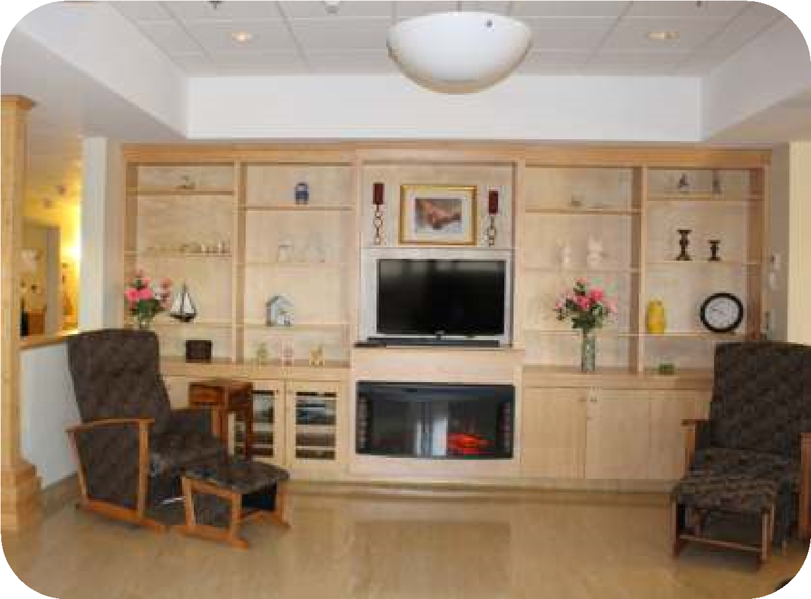

Connecting with Families
Some things that family members may want to know:
- There is a kitchenette between the Multipurpose Room and
Dining Room on the Grey Wing. You are welcome to go in and make yourself a cup of tea or coffee. Due to Public Health Department regulations, visitors are not allowed to enter the Main Kitchen. As there are diet restrictions, please check with staff before offering anyone food or drink.
- There are folding chairs in the closet across from the Main Kitchen if you wish an extra seat while visiting. We ask that you return the chairs to the closet before you leave. Extra chairs left in resident rooms pose a tripping hazard for the resident and our staff.

- There is a patio and enclosed courtyard area off the Main Lounge and Grey Wing accessible with a code. These are great areas to enjoy a visit on warm days.

Some suggestions to make your visit more engaging & rewarding:

- Offer to do nail care or hair care
- Read a favorite book or newspaper
- Assist with writing a letter
- Work on a jigsaw puzzle
- Sort and tidy closets and bureau drawers
- Take a walk through the home or outside on the grounds
- Water plants or pull weeds from the garden
- Participate in “Keeping Busy” activities or other games located in the Multipurpose Room
- Play or watch others interact with the Tovertafel

Family Council
Nakile Family Council provides an opportunity for families to meet with the Leadership Team to gain an understanding of regulations, funding, staffing and other guidelines that impact and influence services and programs at Nakile. These informal meetings also allow family members to socialize with one another while sharing opinions and discussing issues important to the home and their loved one.
Nakile is a scent-free home. Please do not wear scented products of any kind. Due to allergies, we cannot accept poinsettias, lilies or amaryllis plants.

Complaints
If you have any concerns or complaints, we want to know. You may speak with any staff member and ask them to direct you to the RN on duty, the Administrator, or another member of the Leadership Team.
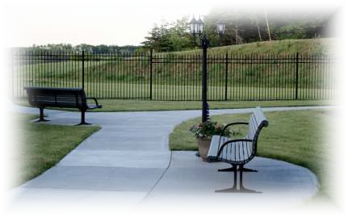

Resident's Bill of Rights
Every Resident has the right to:
- Be fully recognized as an individual
- Receive information relevant to their care
- Receive restorative care maximizing independence
- Participate in their decision making
- Give or refuse consent to any treatment or care
- Live restraint free
- Be treated with respect and courtesy
- Be cared for in a manner that offers privacy
- Live in a clean and safe environment
- Display personal items in resident’s space
- Raise concerns without any fear of reprisal
- Appoint another person to speak on his or her behalf
- Request private consultations with persons in charge of his or her care
- Die within a peaceful environment with personal choices respected
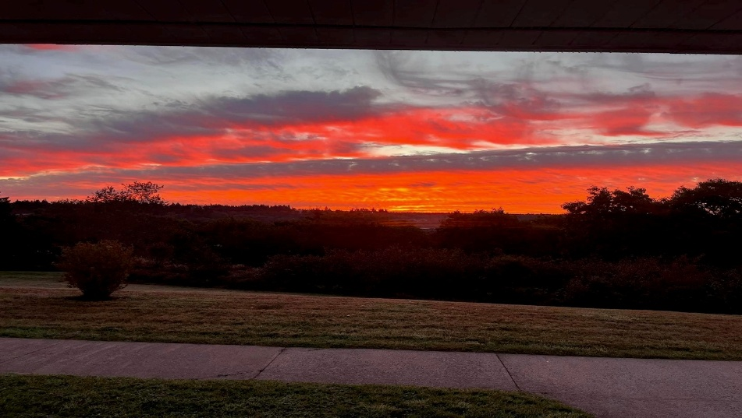

Notes


Nakile Home for Special Care
Larry Muise – Administrator
larry@nakile.ns.ca
35 Nakile Drive, Argyle, NS B0W 1W0
Phone: 902-643-2707 - Fax: 902-643-2862


www.nakilehome.ca
Revised August 2025

